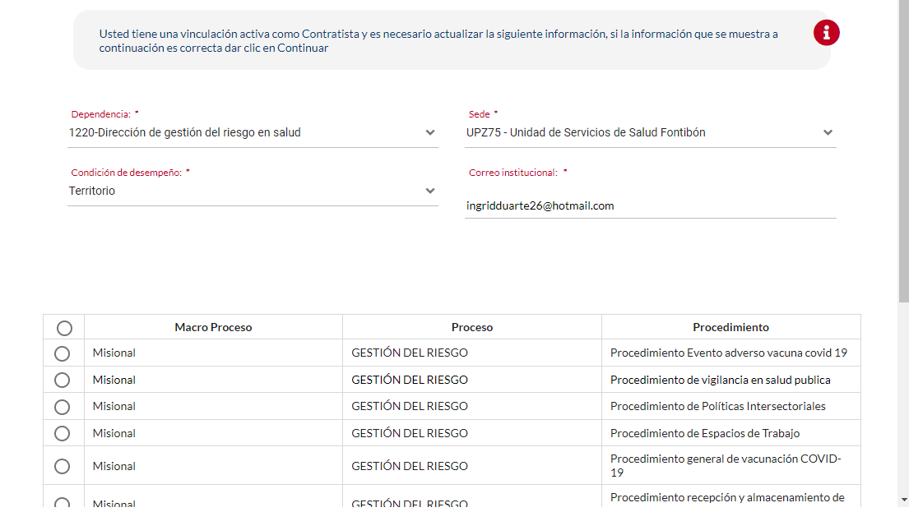
Yessicasandoval85@gmail.com

