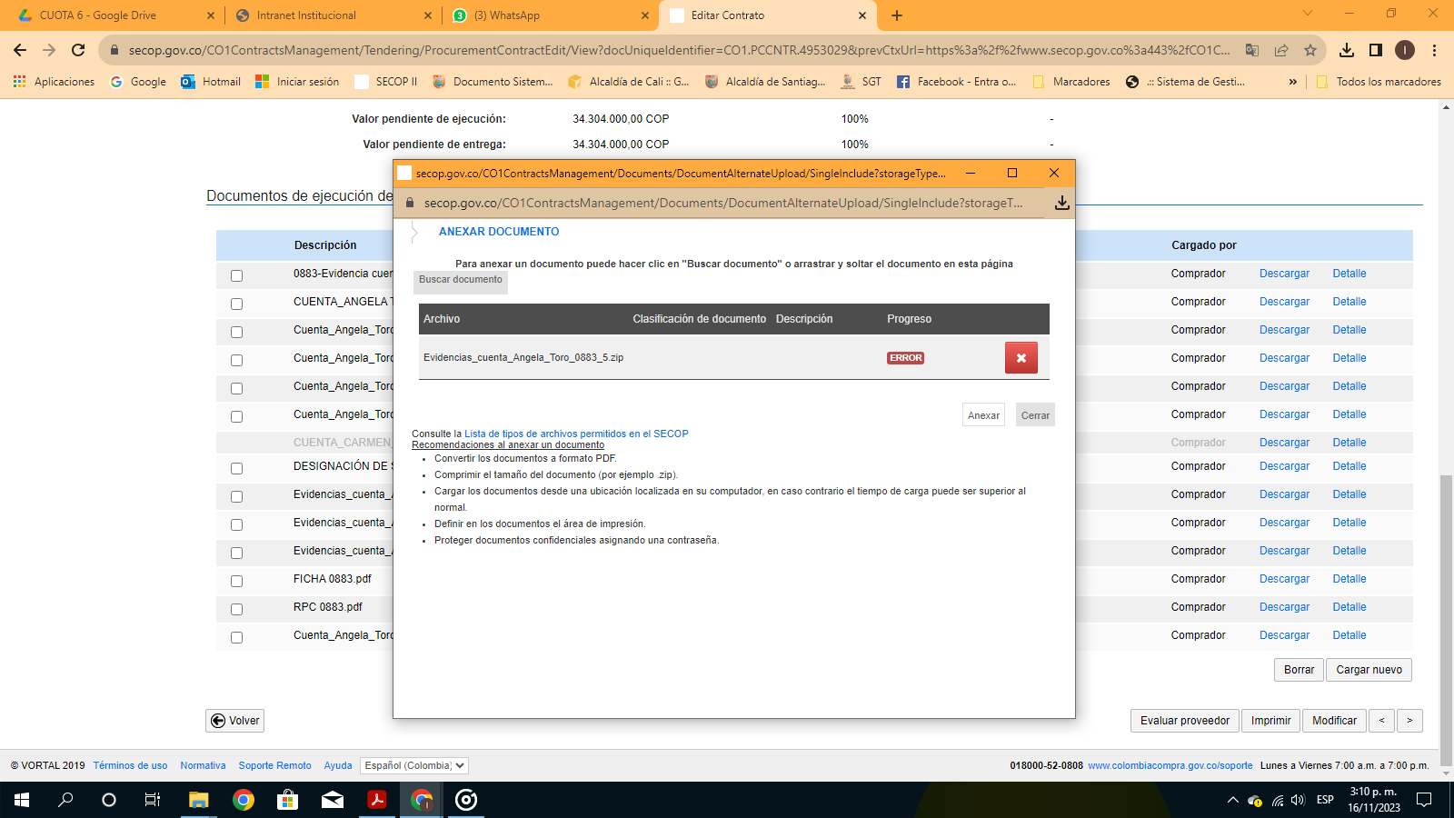
https://drive.google.com/drive/folders/1V7Ut8tuZXwCBndaXnbl4MQjIFbCT1GlF

