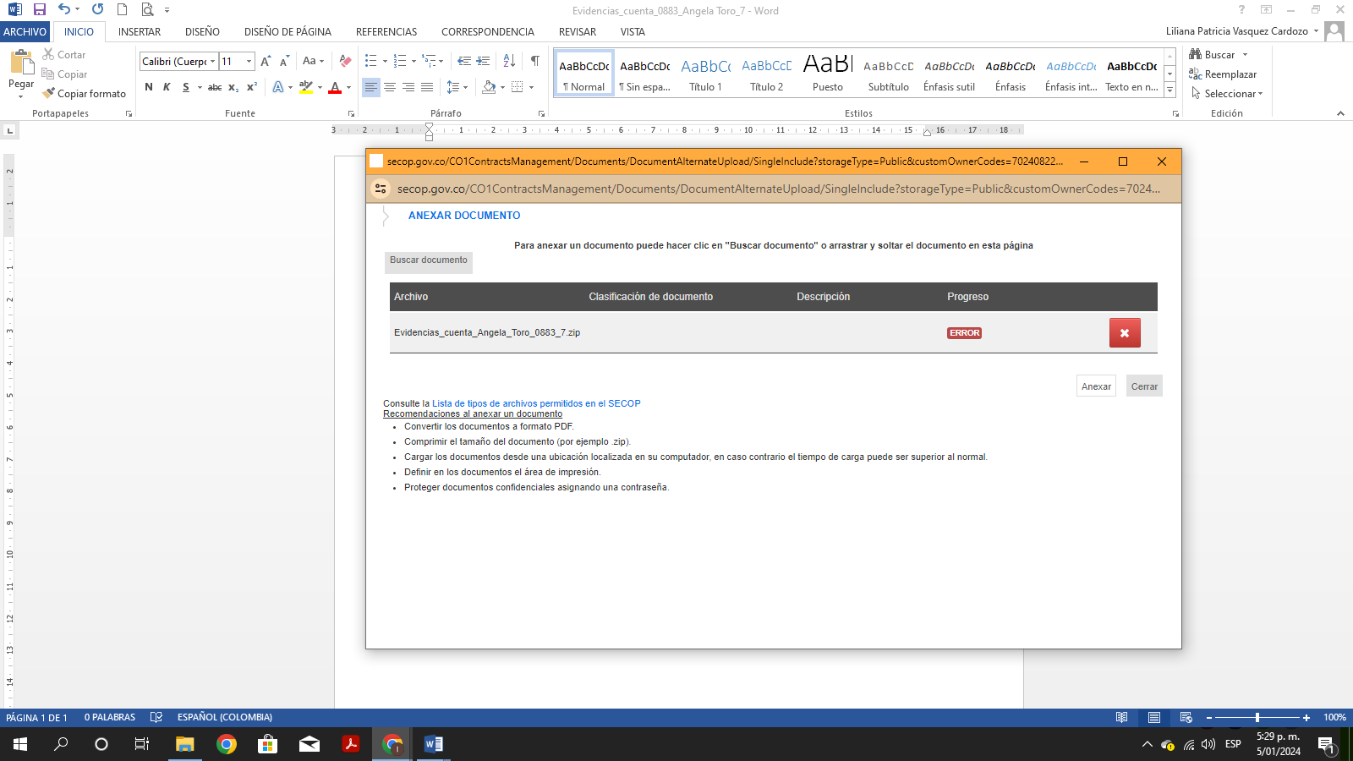
https://drive.google.com/drive/folders/1VmWoqECxfx3Z4tEflxSnj6J65xBsyOvs?usp=drive_link

