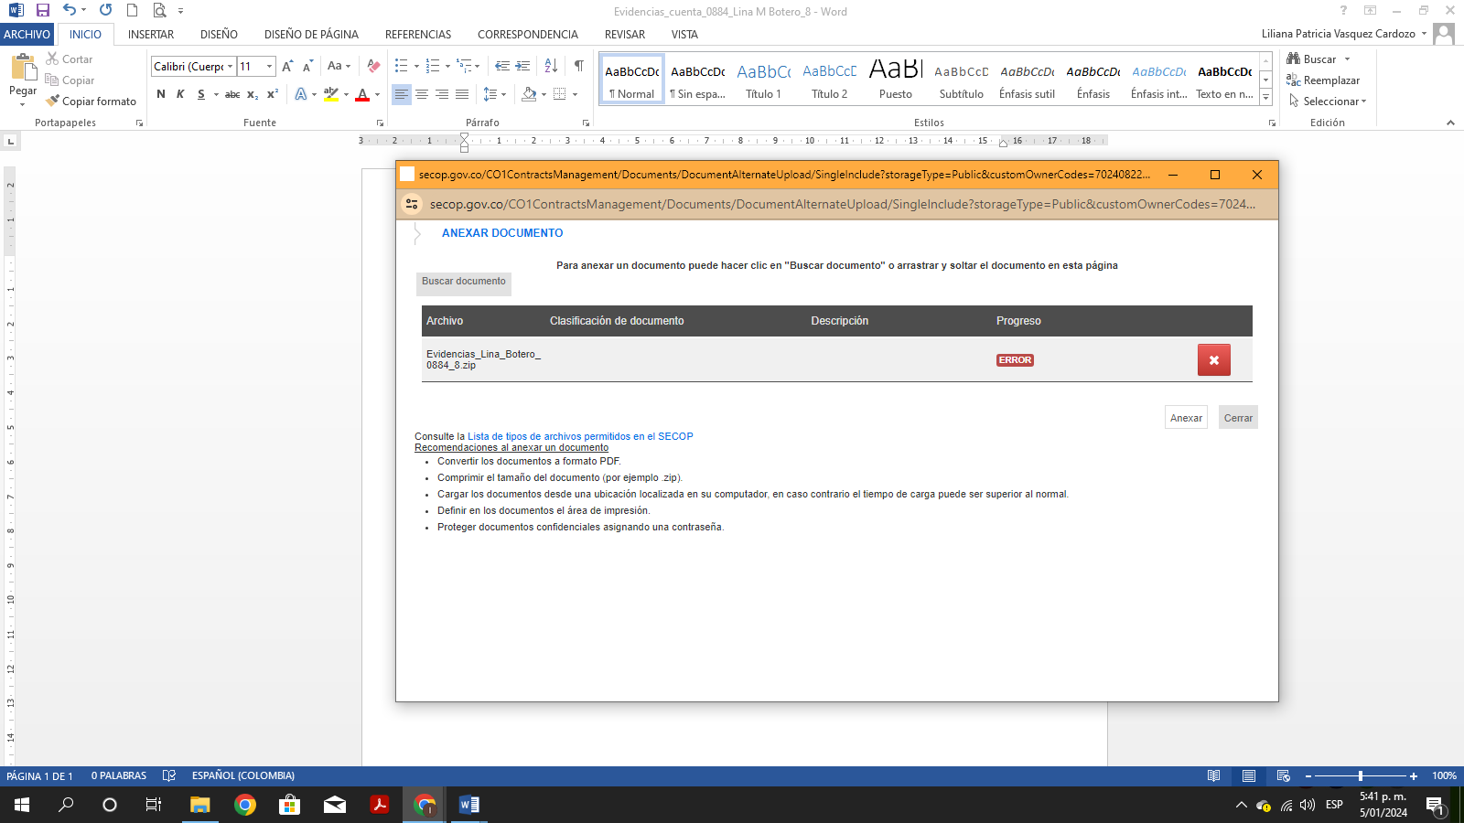
https://drive.google.com/drive/folders/1mksZVwHCMKyjBkF0CmrzNwWy4og5f2Hq?usp=drive_link

