MY ANIMAL ES CAT  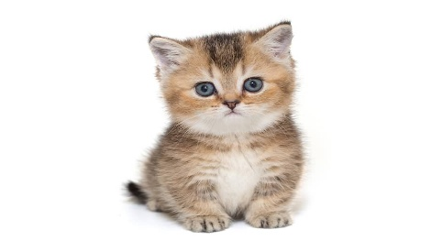 | I am very good at dancing.  
My grandparents’ house.  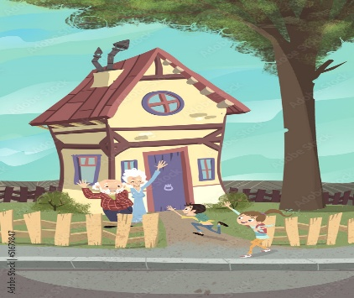 | I like to be alone.
Family is very important to me. | My favorite color is yellow.

