Enlace : https://magru.com.co/producto/estanteria-de-carga-liviana-40-cm-fondo-6-niveles/?utm_source=chatgpt.com
Visado el día 8.08.2026

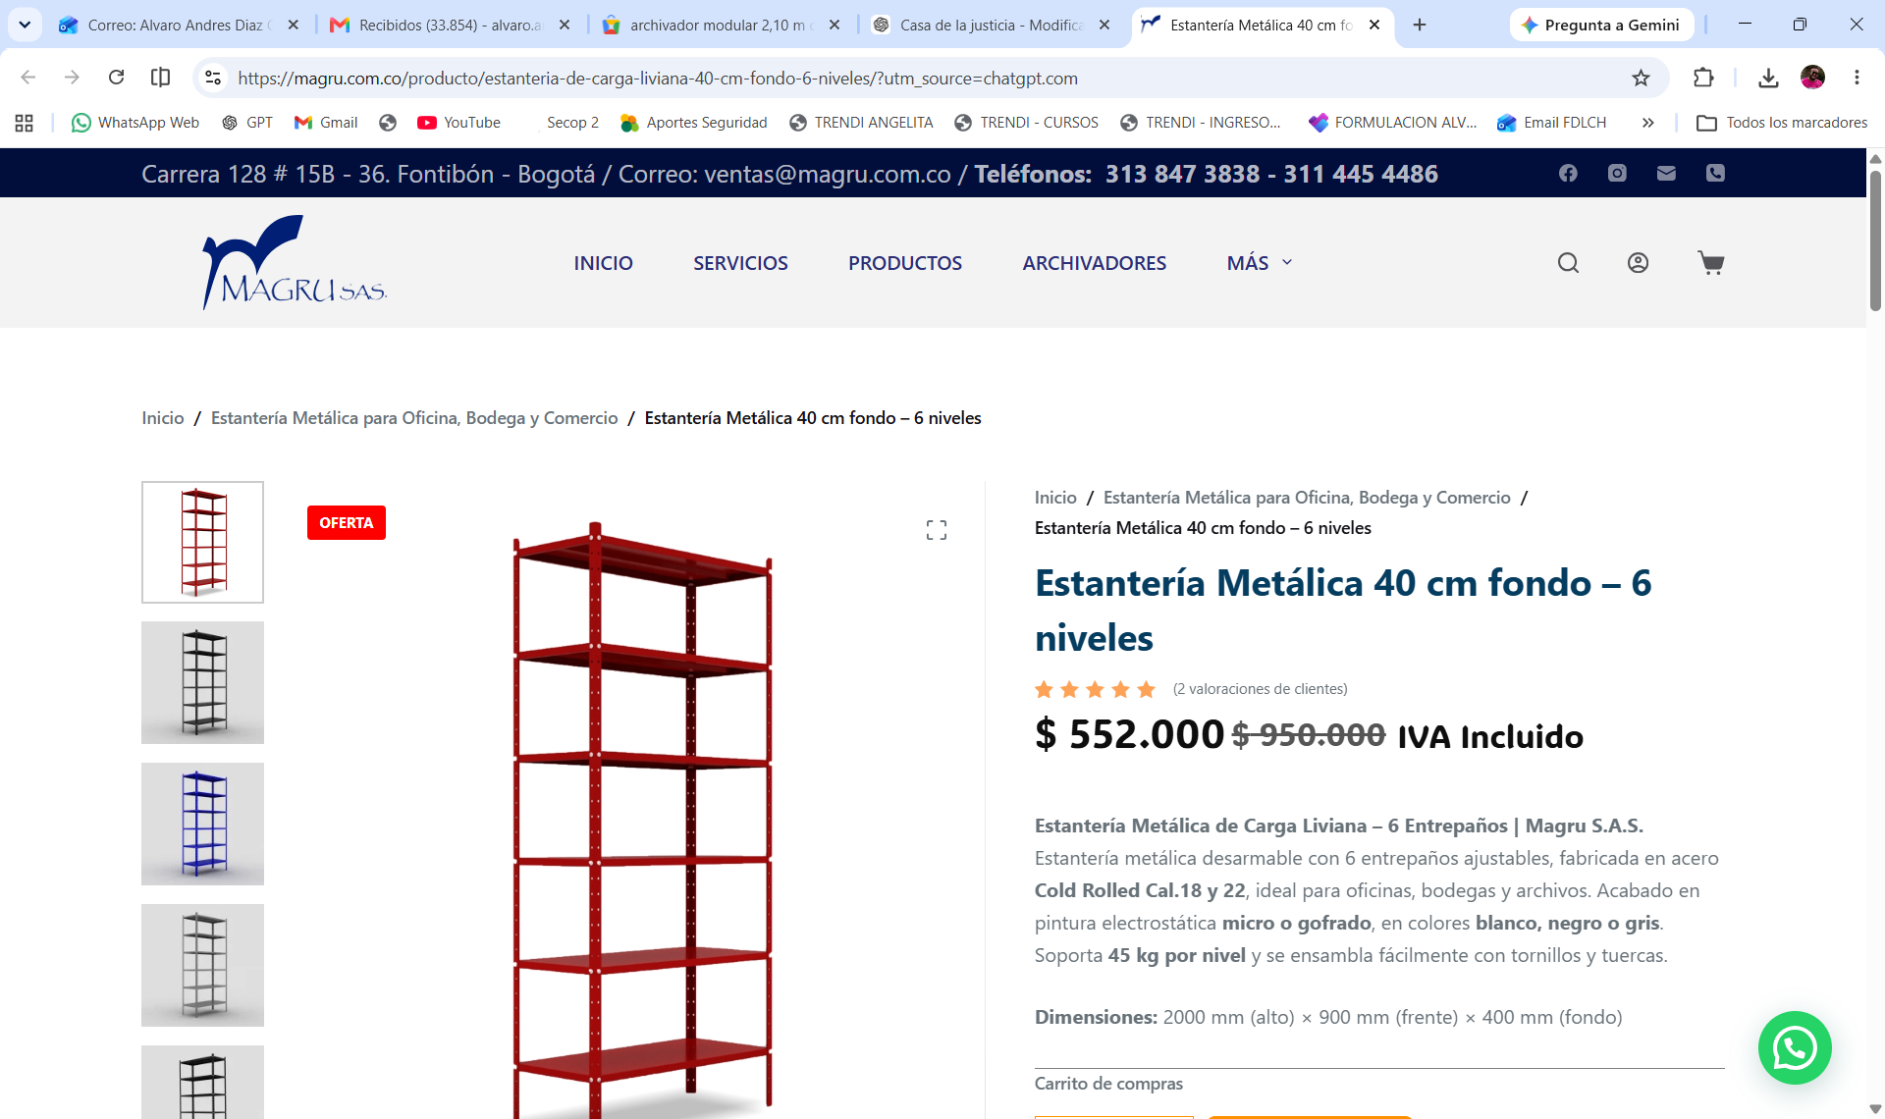

Carpas
https://www.homecenter.com.co/homecenter-co/product/801348/carpa-paredes-ventana-3x3-armable-plegable-impermeable-toldo-color-azul/801348/?kid=shopp_goosho_1430590&shop=1&gad_source=1&gad_campaignid=17339284687&gbraid=0AAAAADt6wnqYi9YVSAS3n48Gy65qPtXzq&gclid=Cj0KCQjwp9vTBhCWARIsANaUrjsa7OoEmsOx4n3lIixdbRksUfbKcbHYx6zIE-IGiG7naNg3Au_r-wUaAiavEALw_wcB
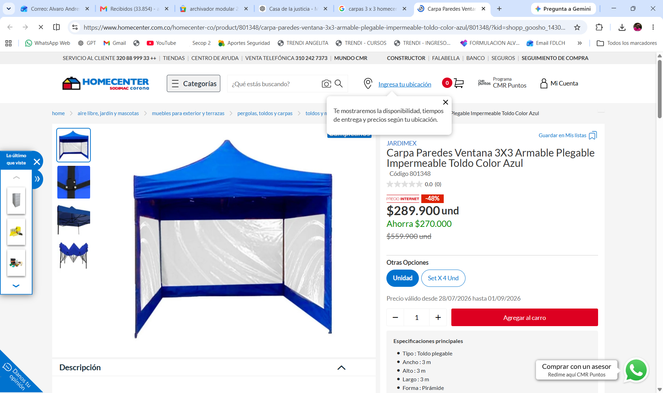

Silla plástica
https://www.homecenter.com.co/homecenter-co/product/647200/silla-con-brazos-plastico-cipres-wengue/647201/
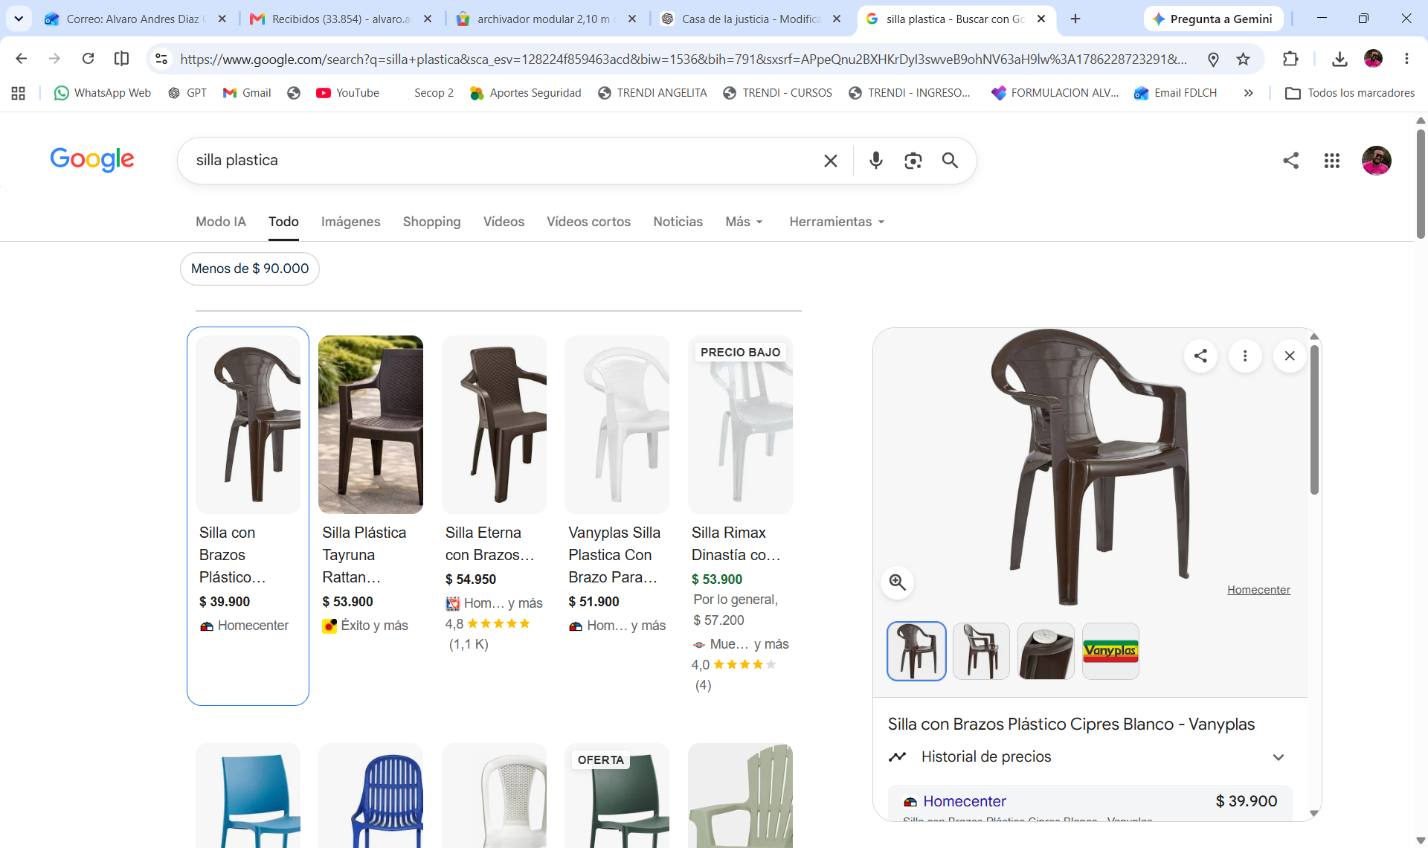

Mesa plegable tipo portafolio plástica

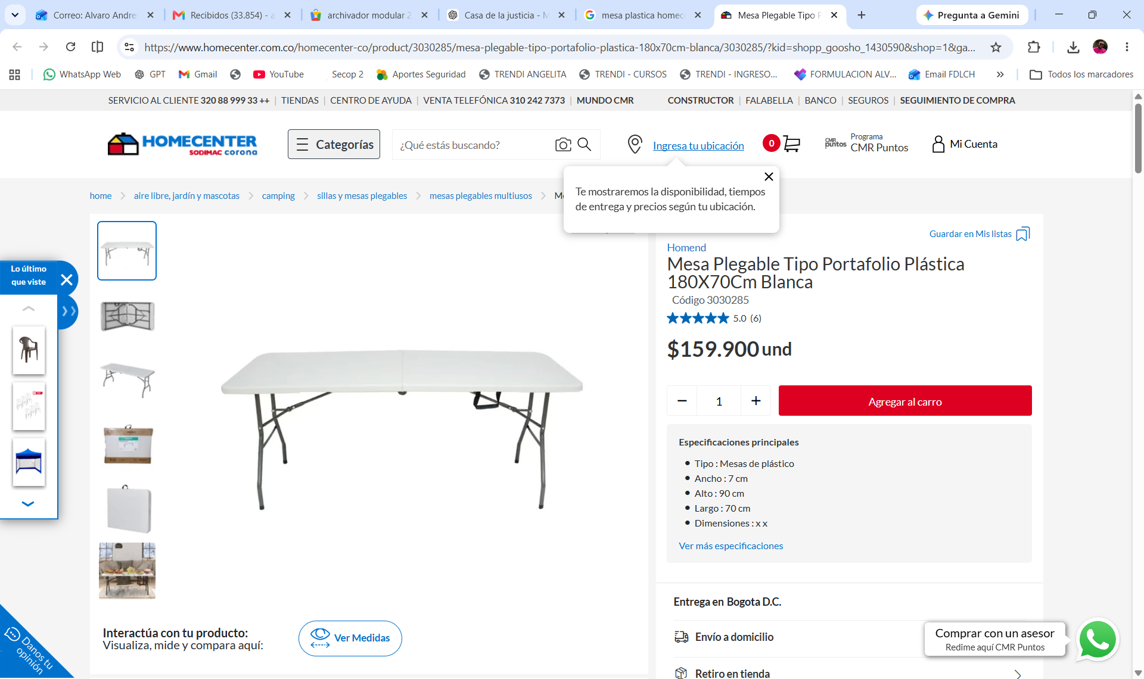

Parlante
https://www.homecenter.com.co/homecenter-co/product/3014728/parlante-profesional-torre-de-sonido-bluetooth-sonivox-vs-ss2590/3014728/

Éxito

https://www.exito.com/parlante-kalley-k-boomx1-negro-107w-negro-parlante-con-bluetooth-3249374/p

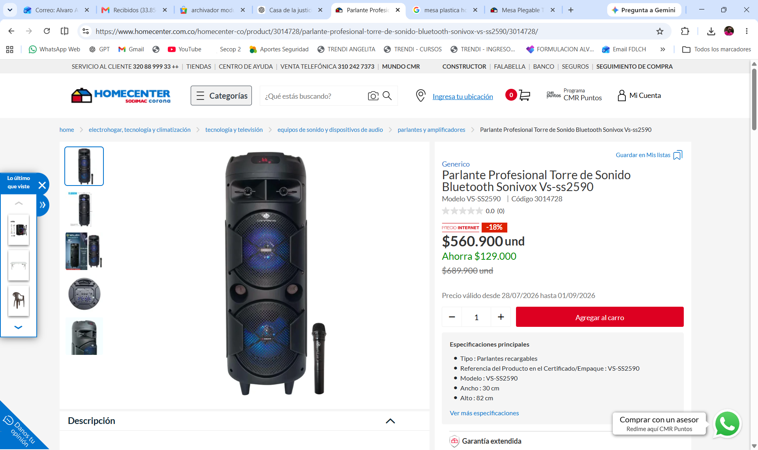

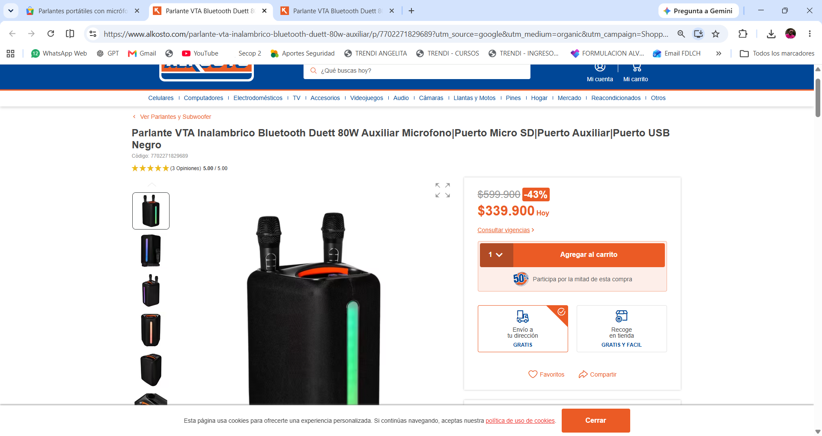
https://www.alkosto.com/parlante-vta-inalambrico-bluetooth-duett-80w-auxiliar/p/7702271829689?utm_source=google&utm_medium=organic&utm_campaign=Shopping-Organico&srsltid=AfmBOop72bt7uu6D_vAjiGRN_dM_g3-r3_upZ1Pp4F7_4ocz9gLmkmvfdvI

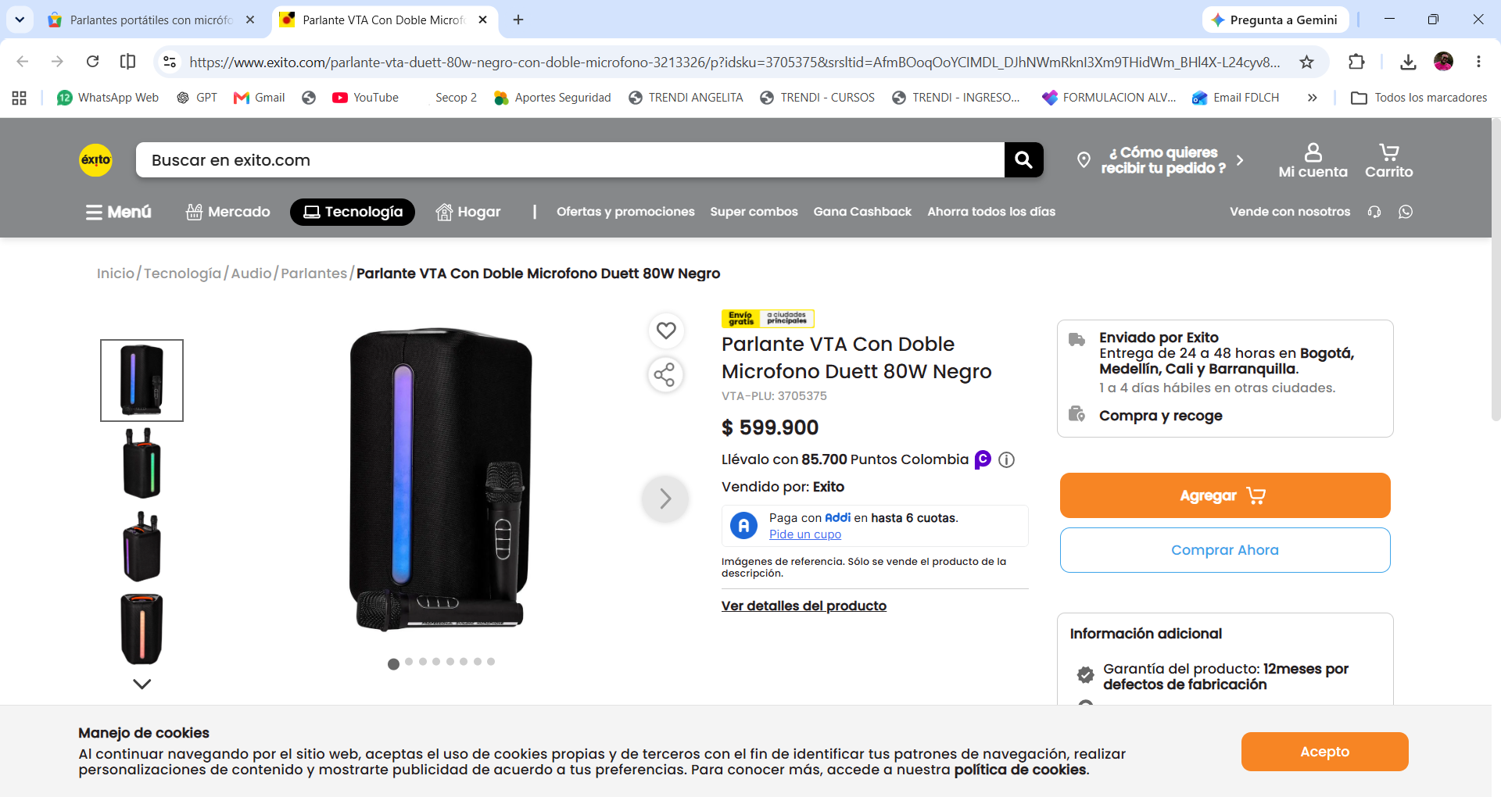

https://www.exito.com/parlante-vta-duett-80w-negro-con-doble-microfono-3213326/p?idsku=3705375&srsltid=AfmBOoqOoYCIMDL_DJhNWmRknI3Xm9THidWm_BHl4X-L24cyv8wEC28DoM4

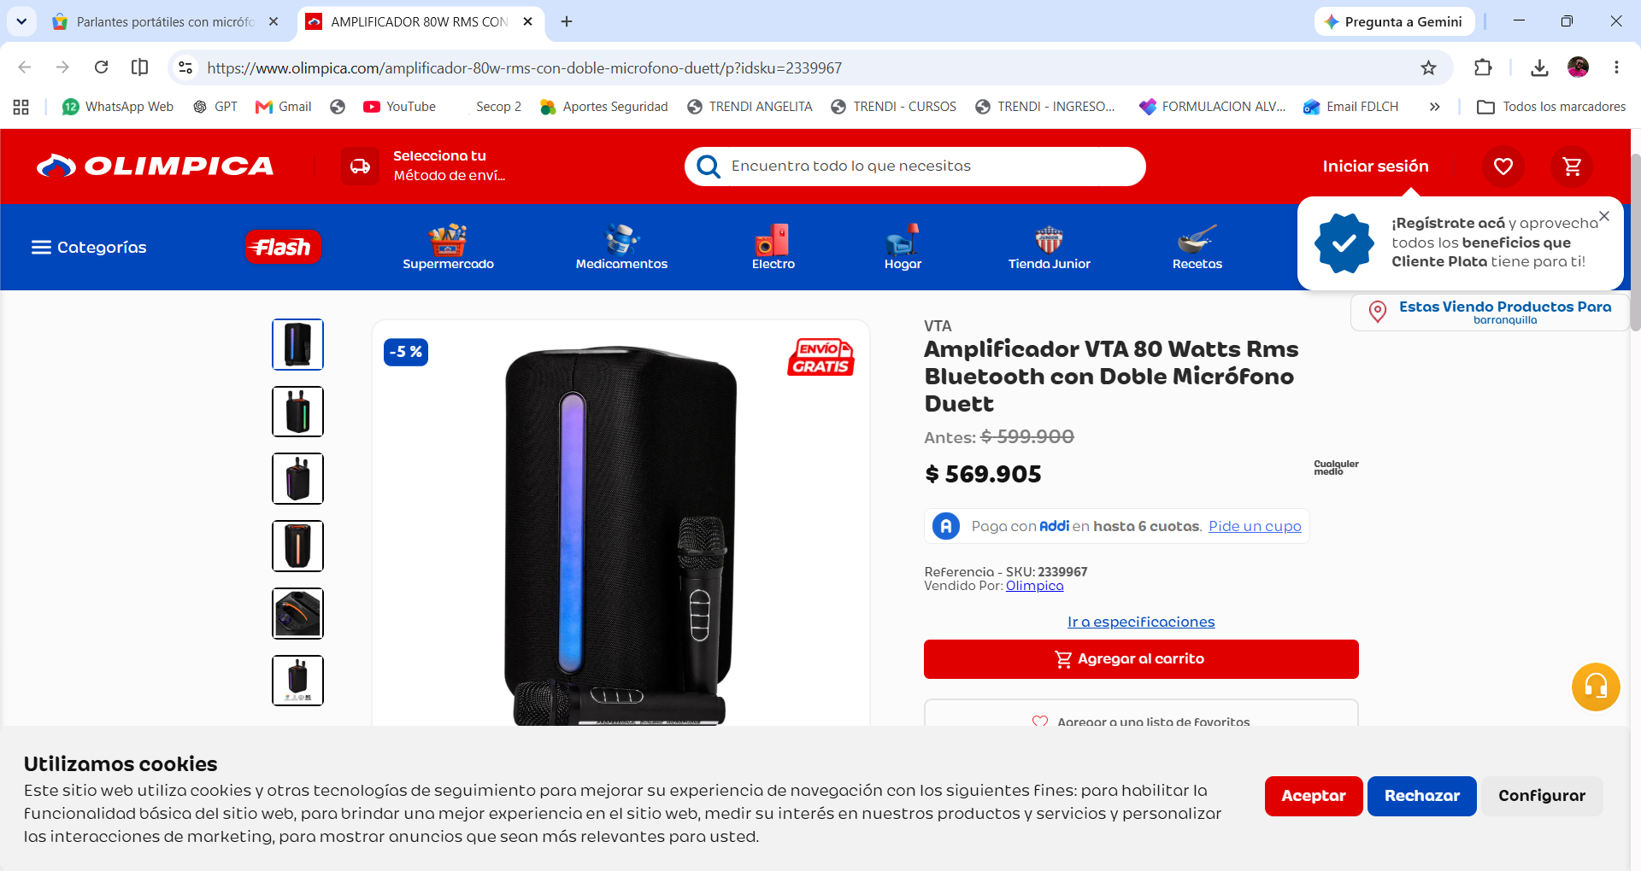

https://www.olimpica.com/amplificador-80w-rms-con-doble-microfono-duett/p?idsku=2339967&gclsrc=aw.ds&&kb=ga_pm_23559472306_&gad_source=1&gad_campaignid=23554837652&gbraid=0AAAAADiQW2HJ7-LhVmjgo-PTXMEpRbQMw&gclid=CjwKCAjwwrPVBhA1EiwAv_YO-aYqH1oupWULa7BUKpJ9fVpXUO56N5JfjLs1HveBdFVmMDgHWimrlhoCt0EQAvD_BwE

